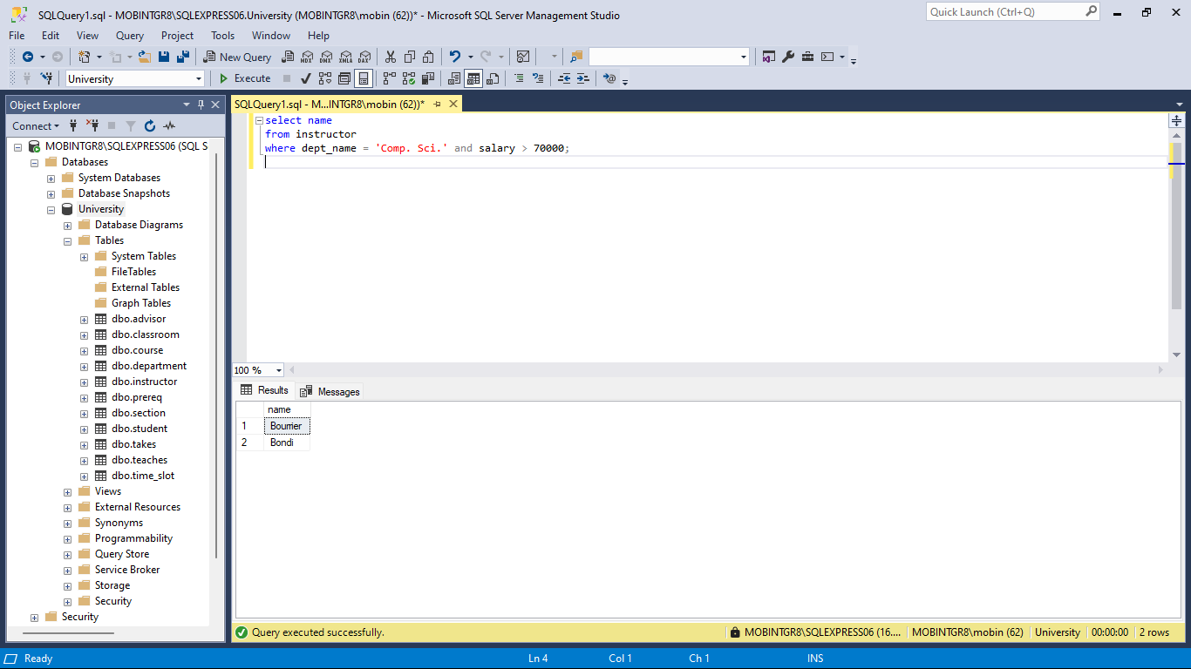

**Query 1: Find the names of all instructors.**

select name

from instructor;

name

Lembr

Bawa

Yazdi

Wieland

DAgostino

Liley

Kean

Atanassov

Moreira

Gustafsson

Bourrier

Bondi

Soisalon-Soininen

Morris

Arias

Murata

Tung

Luo

Vicentino

Romero

Lent

Sarkar

Shuming

Konstantinides

Bancilhon

Hau

Dusserre

Desyl

Jaekel

McKinnon

Gutierrez

Mingoz

Pimenta

Yin

Sullivan

Voronina

Kenje

Mahmoud

Pingr

Ullman

Levine

Queiroz

Valtchev

Bietzk

Choll

Arinb

Sakurai

Mird

Bertolino

Dale

**Query 2: Find the department names of all instructors.**

select dept_name

from instructor;

dept_name

Accounting

Athletics

Athletics

Pol. Sci.

Psychology

Languages

English

Statistics

Accounting

Elec. Eng.

Comp. Sci.

Comp. Sci.

Psychology

Marketing

Statistics

Athletics

Athletics

English

Elec. Eng.

Astronomy

Mech. Eng.

Pol. Sci.

Physics

Languages

Pol. Sci.

Accounting

Marketing

Languages

Athletics

Cybernetics

Statistics

Finance

Cybernetics

English

Elec. Eng.

Physics

Marketing

Geology

Statistics

Accounting

Elec. Eng.

Biology

Biology

Cybernetics

Statistics

Statistics

English

Marketing

Mech. Eng.

Cybernetics

**Query 3: Force the elimination of duplicates.**

select distinct dept_name

from instructor;

dept_name

Accounting

Astronomy

Athletics

Biology

Comp. Sci.

Cybernetics

Elec. Eng.

English

Finance

Geology

Languages

Marketing

Mech. Eng.

Physics

Pol. Sci.

Psychology

Statistics

**Query 4: “Find the names of all instructors in the Computer Science department who have salary greater than $70,000.**

select name

from instructor

where dept_name = 'Comp. Sci.' and salary > 70000;

name

Bourrier

Bondi

**Query 5: Retrieve the names of all instructors, along with their department names and department building name.**

select name, instructor.dept_name, building

from instructor, department

where instructor.dept_name = department.dept_name;

name dept_name building

Lembr Accounting Saucon

Bawa Athletics Bronfman

Yazdi Athletics Bronfman

Wieland Pol. Sci. Whitman

DAgostino Psychology Thompson

Liley Languages Linderman

Kean English Palmer

Atanassov Statistics Taylor

Moreira Accounting Saucon

Gustafsson Elec. Eng. Main

Bourrier Comp. Sci. Lamberton

Bondi Comp. Sci. Lamberton

Soisalon-Soininen Psychology Thompson

Morris Marketing Lambeau

Arias Statistics Taylor

Murata Athletics Bronfman

Tung Athletics Bronfman

Luo English Palmer

Vicentino Elec. Eng. Main

Romero Astronomy Taylor

Lent Mech. Eng. Rauch

Sarkar Pol. Sci. Whitman

Shuming Physics Wrigley

Konstantinides Languages Linderman

Bancilhon Pol. Sci. Whitman

Hau Accounting Saucon

Dusserre Marketing Lambeau

Desyl Languages Linderman

Jaekel Athletics Bronfman

McKinnon Cybernetics Mercer

Gutierrez Statistics Taylor

Mingoz Finance Candlestick

Pimenta Cybernetics Mercer

Yin English Palmer

Sullivan Elec. Eng. Main

Voronina Physics Wrigley

Kenje Marketing Lambeau

Mahmoud Geology Palmer

Pingr Statistics Taylor

Ullman Accounting Saucon

Levine Elec. Eng. Main

Queiroz Biology Candlestick

Valtchev Biology Candlestick

Bietzk Cybernetics Mercer

Choll Statistics Taylor

Arinb Statistics Taylor

Sakurai English Palmer

Mird Marketing Lambeau

Bertolino Mech. Eng. Rauch

Dale Cybernetics Mercer

**Query 6: For all instructors in the university who have taught some course, find their names and the course ID of all courses they taught.**

select name, course_id

from instructor, teaches

where instructor.ID= teaches.ID;

name course_id

Lembr 200

Lembr 843

Bawa 457

Wieland 545

Wieland 581

Wieland 591

DAgostino 338

DAgostino 338

DAgostino 352

DAgostino 400

DAgostino 400

DAgostino 482

DAgostino 599

DAgostino 642

DAgostino 663

DAgostino 867

DAgostino 962

DAgostino 972

DAgostino 991

Liley 192

Kean 366

Kean 808

Atanassov 603

Atanassov 604

Gustafsson 169

Gustafsson 169

Gustafsson 561

Gustafsson 631

Bourrier 949

Bourrier 960

Bondi 274

Bondi 571

Bondi 747

Morris 242

Morris 313

Morris 696

Morris 791

Morris 795

Tung 401

Tung 421

Tung 692

Luo 679

Vicentino 793

Romero 105

Romero 105

Romero 476

Romero 489

Lent 626

Sarkar 867

Shuming 468

Jaekel 334

Jaekel 852

Mingoz 137

Mingoz 304

Mingoz 319

Mingoz 349

Mingoz 362

Mingoz 362

Mingoz 362

Mingoz 426

Mingoz 445

Mingoz 527

Pimenta 875

Sullivan 694

Voronina 239

Voronina 376

Voronina 443

Voronina 443

Voronina 612

Voronina 959

Mahmoud 486

Mahmoud 493

Mahmoud 704

Mahmoud 735

Mahmoud 735

Mahmoud 864

Ullman 200

Ullman 345

Ullman 408

Ullman 408

Ullman 760

Ullman 974

Queiroz 559

Valtchev 415

Valtchev 702

Bietzk 158

Choll 461

Sakurai 258

Sakurai 270

Sakurai 468

Sakurai 960

Dale 158

Dale 237

Dale 237

Dale 496

Dale 629

Dale 748

Dale 802

Dale 893

Dale 927

**Query 7: only instructor names and course identifiers for instructors in the Computer Science department**

select name, course_id

from instructor, teaches

where instructor.ID= teaches.ID and instructor.dept_name = 'Comp. Sci.';

name course_id

Bourrier 949

Bourrier 960

Bondi 274

Bondi 571

Bondi 747

Query 8: **Ordering the Display of Tuples**

select *

from instructor

order by salary desc, name asc;

ID name dept_name salary

19368 Wieland Pol. Sci. 124651.41

74420 Voronina Physics 121141.99

96895 Mird Marketing 119921.41

95709 Sakurai English 118143.98

90376 Bietzk Cybernetics 117836.50

34175 Bondi Comp. Sci. 115469.11

50330 Shuming Physics 108011.81

48507 Lent Mech. Eng. 107978.47

74426 Kenje Marketing 106554.73

6569 Mingoz Finance 105311.38

37687 Arias Statistics 104563.38

63287 Jaekel Athletics 103146.87

77346 Mahmoud Geology 99382.59

16807 Yazdi Athletics 98333.65

63395 McKinnon Cybernetics 94333.99

99052 Dale Cybernetics 93348.83

25946 Liley Languages 90891.69

73623 Sullivan Elec. Eng. 90038.09

79653 Levine Elec. Eng. 89805.83

4233 Luo English 88791.45

52647 Bancilhon Pol. Sci. 87958.01

48570 Sarkar Pol. Sci. 87549.80

28400 Atanassov Statistics 84982.92

3199 Gustafsson Elec. Eng. 82534.37

3335 Bourrier Comp. Sci. 80797.83

65931 Pimenta Cybernetics 79866.95

43779 Romero Astronomy 79070.08

81991 Valtchev Biology 77036.18

15347 Bawa Athletics 72140.88

31955 Moreira Accounting 71351.42

58558 Dusserre Marketing 66143.25

35579 Soisalon-Soininen Psychology 62579.61

4034 Murata Athletics 61387.56

22591 DAgostino Psychology 59706.49

78699 Pingr Statistics 59303.62

90643 Choll Statistics 57807.09

95030 Arinb Statistics 54805.11

97302 Bertolino Mech. Eng. 51647.57

41930 Tung Athletics 50482.03

59795 Desyl Languages 48803.38

79081 Ullman Accounting 47307.10

72553 Yin English 46397.59

80759 Queiroz Biology 45538.32

64871 Gutierrez Statistics 45310.53

57180 Hau Accounting 43966.29

36897 Morris Marketing 43770.36

28097 Kean English 35023.18

42782 Vicentino Elec. Eng. 34272.67

50885 Konstantinides Languages 32570.50

14365 Lembr Accounting 32241.56

**Query 9: find the names of instructors with salary amounts between $90,000 and $100,000**

select name

from instructor

where salary between 90000 and 100000;

name

Yazdi

Liley

McKinnon

Sullivan

Mahmoud

Dale

**Query 10: The *c1* relation, listing courses taught in Fall 2017**

select name, course_id

from instructor, teaches

where (instructor.ID, dept_name) = (teaches.ID, 'Biology');

course_id

105

237

242

304

334

486

960